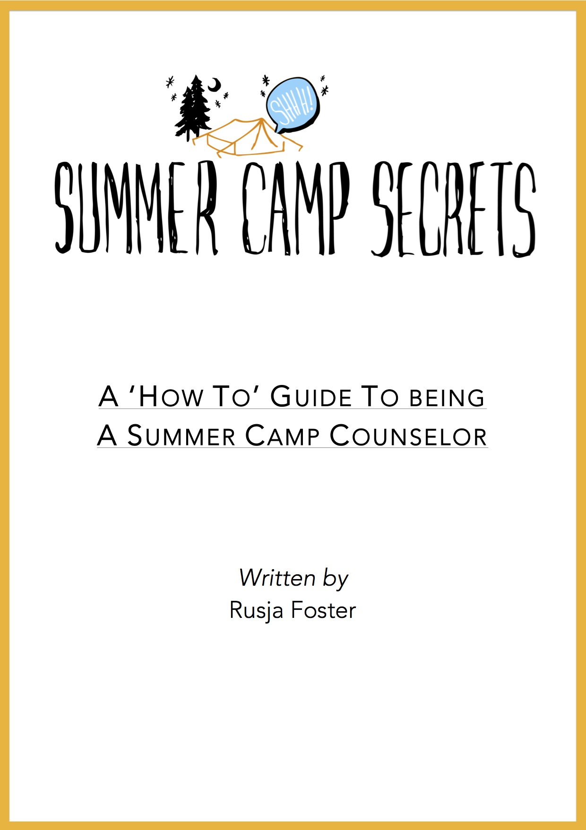

Fact:

Being a summer camp counselor will be the best thing you ever do.

What are you waiting for?

“From the outside looking in, you will never understand it. From the inside looking out, you will never be able to explain it“

Contents

Introduction Page 3

Detailing who I am, why I went to summer camp, what summer camp actually is, my experiences there and why I love it so much that I decided to write a book about it.

Chapter 1: The Diary (So You Know What You’re Getting Into) Page 6

My daily diary from my first summer at Camp Sloane YMCA, recounting the trials and tribulations of life at summer camp, stories of friends and funny kids, games and laughs and, of course, boys and drama. [All names have been changed].

Chapter 2: Applying To Summer Camp Page 66

Everything you need to know to help you get a job at summer camp in the USA. Information about the different summer camp agencies, why camp is so awesome, the application process, interview tips, and visa help.

Chapter 3: The Art Of Being A Great Camp Counselor Page 128

Tips and advice to help you become the best camp counselor you can be once you get to camp. This chapter is full of ideas such as help with how to write a lesson plan, ice breaker games and questions to help you bond with your kids, how to build a campfire, and how to deal with a homesick camper.

Chapter 4: Absolutely Everything Else Page 154

This chapter is for all the other little details you might want to know about summer camp, like what to pack for camp, things you might learn throughout the summer, what happens of day off, how you get paid, planning your post-camp travels and much, much more.

Glossary & Resources Page 193

At the back of the book you’ll find a glossary of all these funny camp words and phrases to give you a little bit more of an understanding of how summer camp works. There is also a resources page where you can find references and links to everything discussed in the book, so you can get going with some more of your own research about summer camp.

Introduction

My name is Rusja. But don’t worry; no one else can pronounce it either, so everyone just calls me Roo. I’ve been working at summer camp for the last 5 years, and will be going back for the 6th time this coming summer. How did I end up there and what is it like? Keep reading to find out why I think it’s the best place (and the best job) in the world!

Around November 2010 I decided that I wanted to spend the next summer doing something awesome. I was in my final year at University and wanted to use my summer wisely, instead of just wasting it with a few random trips here and there like I had the summers before. I was already planning to go on a round the world trip the following year, so knew I had about 4 months to do something epic between graduating University and heading off on my travels.

I’d always thought about doing Summer Camp (BUNAC and a bunch of the other agencies had done a couple of talks and recruitment events at my Uni over the years), and had even started an account with BUNAC the year before but never really followed through with it for one reason or another. But this time I thought ‘why the hell not?’ and applied.

I was told I didn’t have enough ‘formal’ experience working with children (apparently babysitting and being around kids my whole life didn’t really count), but since I was still a student, I could apply to be ‘support staff’, which basically meant I would end up working in the kitchen, doing maintenance or in the office. I didn’t really give it much thought as to what I would be doing, I’d just set my heart on working at camp for the summer (especially as it meant I would make money and have time to travel afterwards), so ploughed on through the application.

Then in January I got a message from the Camp Director at Camp Sloane YMCA, saying he wanted to interview me for an office role. I was super excited and, after an awesome interview and chat over Skype, I found out I’d got the job!

The last few months of Uni passed in a blur of excitement about camp. I wasn’t even nervous, just so excited for the new adventure. I got all my documents together, had all my flight stuff sorted by BUNAC and eventually got my visa! Then about 2 weeks before I was due to head out to America, I got an email from the camp director saying that he wanted to discuss some alterations to my job for the summer. I was baffled and really didn’t have a clue what it could be. Eventually we spoke and he told me he wanted me to do some Media stuff, as well as work in the office. Basically the idea was that I’d teach filmmaking to the campers, take photos around camp, make videos of camp events and be in charge of the camp’s social media. I was studying Film at the time, so it seemed like a perfect fit. I was thrilled, and more excited than ever!

Without sounding too cheesy or predictable, that summer at camp really changed my life. I found out who I was and who I wanted to be; I grew in confidence; I learned new skills; I made some of the best friends I’ve ever had; and I can honestly say that I have no idea what I’d be doing now if I hadn’t spent the summer of 2011 at camp. Summer camp has become the driving force in my life. It is all I want to do and all I want to keep on doing for the foreseeable future. I even have dreams of one day starting my own summer camp in the UK – to bring that magic across the pond for all the English kids to enjoy.

Summer 2011 was one of the best summers I’ve ever had, and I have returned to Sloane every year since (now as the Marketing Director); returned to my ‘home away from home’; returned to my Sloane family.

Throughout my time at camp I wrote a daily diary – this book includes the account of my first summer spent at Camp Sloane YMCA. I hope these tales of mine, alongside the tips and advice in the final chapters, can give you some insight into what working at a summer camp in the USA is really like, and maybe even persuade you to give it a try!

So What Is Summer Camp?

Every summer, thousands of American kids leave their homes and families and head off into the woods or lakeside locations to spend the next 2-8 weeks having the time of their lives living with their friends in cabins or tents, doing all sorts of awesome activities, making s'mores over the camp fire, singing songs and generally being a little bit silly.
Summer Camp is a glorious place where everyone is free to be themselves, without judgement or ridicule. It is a place kids go to make new friends, learn new skills and to have a break from their everyday home life.
But of course, there need to be some adults to keep these unruly children in check. And that's where YOU come in. Every year, summer camps from the USA and Canada look across the globe for staff members who can teach a variety of skills, from basketball to swimming, from horse-riding to skateboarding, from photography to sailing and many more. The list of activities you could teach is pretty endless.
To be a summer camp counselor you need to be someone who LOVES spending time with kids (you'd be surprised at how many people realise they don't actually like children once they get to camp!), have a particular skill you could teach (some camps hire 'general counselors' too, so this isn't a massive necessity if you're suddenly thinking you don't do anything well enough to teach it), and be willing to work 24 hours a day, for 6 days a week, for a minimum of 9 weeks.
But if you're willing and able to spend those 9 weeks of your summer surrounded by beautiful scenery and amazing people, having fun, dressing up, singing a lot, and making some of the best friends you'll ever have, then keep reading for more info on how to get yourself to Summer Camp and have the best summer of your life. Oh and you get to travel the USA for 30 days after you leave camp too.
It is honestly the best job you'll ever have.
But I'm assuming you want a little bit more information than that, especially if you've found this book while researching working at summer camp and whether or not it might be a good option for you this summer.
So read on, and hopefully I can help you on your way to having the summer of a lifetime!

~
Chapter 1: The Diary

Day 1. Fri June 17th 2011: And so it begins.

7am
I can’t believe today has finally arrived. I’ve been waiting for this since January when I got hired and now today is, well, today! After all the planning, the packing, and the visa getting, I really am about to spend the summer at camp in the USA. I always wanted to do this, and I don’t know why it took me until my third year of Uni to actually get my arse into gear, but I’m so proud of myself that I actually did. Right, time to get up and off to the airport. I’ve arranged to meet a couple of other people going to Camp Sloane at Heathrow – it’s quite cool ‘cos we’ve got a staff group on Facebook, so we’ve been able to figure out who’s on the same flight so we can all travel to camp together. I hope I recognise them and it’s not that weird kind of awkward when you’ve been talking online but then face-to-face it’s not the same.

11am
Phew. They’re all cool. Arrived at the airport and saw a group of people standing together so figured it must be them. Went over and said hi. Was looking for Jess, ‘cos she’s the one I’ve been chatting to most – she’s really lovely. Then there’s Tiffany, John (who spent the entire night in the airport!) and Rob, who we randomly bumped into at security. Feel so much more relaxed now that I’ve got a group I can hang with on the flight. None of them have been to camp before either, so we’re all in the same boat.
Said goodbye to our mums and went through security and now waiting the other side in departures for our flight.

I love airports. So much fun stuff to play with – wish I could buy a new camera, seeing as I’m going to be the camp photographer, but I suppose my old SLR will have to do.

12:30pm
On the plane, just waiting to take off. Jess really kindly swapped seats with me ‘cos I was trapped in one of those rubbish middle-of-the-middle seats and she had an aisle and she didn’t mind either way. There’s about 40 other people sitting around me all travelling to New York with BUNAC, most going to camps on the East coast, but a few just heading to NYC on the summer work program – I’d be so nervous doing that I think… just heading to a city and finding work. It sounds kind of daunting.

4pm
Urgh. I hate flying. So bored. John’s sat behind me and he keeps poking me and sticking his tongue out in a jokey sort of way. Think he’s going to be fun this summer.

4:45pm
Just found two more people on the flight who are going to Sloane. Sofie, a girl from Portugal, and Hugo, who will be working in the office with me! Awesome.

9pm (4pm New York Time)
Finally landed a few hours ago. Took ages to get everyone off the plane and through customs - they asked so many questions about where I was going and what I was doing there. Those customs guys are quite scary. They really like to stare you down. And it’s so awkward when you have to stare at the little camera thing while they take your picture. I swear they probably all look at the photos later and laugh.

Anyway, now we’re all gathered in the Arrivals hall waiting for the last of the Bunac-ers to come through. It’s pretty cool actually – there were a couple of Bunac reps here to meet us when we came through with our bags. We’re just waiting for Tiffany now. When she was going through immigration they pulled her aside into a little room! Uh-oh. We’ve got her bags and everything, so I hope it’s all good?!

Oh. There she is. Finally. Something to do with her losing her passport once or not having an ESTA (tourist visa) one time ages ago. She says it always happens. On we go.

5:30pm (NYT)
I’m so tired and my head is totally fucked from the time difference – I’m just trying to push through and stay awake until a decent hour though. We’re at the hostel now – the HI-NY hostel (on 103rd & Amsterdam) – it’s quite nice actually. I’m in a room with Jess and Tiffany (and 7 other people all going off to different camps tomorrow. We all piled on a coach from the airport and came straight here. Driving over the bridge and into Manhattan was incredible… I’ve been to New York once before but have never really seen the city skyline from that angle – it’s exactly how you always imagine it.

We don’t go to camp until tomorrow, so we’ve got some time tonight to go exploring in the city. Time to see if I can remember how to find my way around since the last time I was here a few years ago!

9:15pm
Finally back at the hostel after a mammoth few hours traipsing around the city. We were all going to go out as a big group, but the boys disappeared so it ended up just being me, Tiffany and Jess. Quite nice to have some time to get to know each other properly without the boys though. We headed straight to Times Square for the ultimate tourist attractions (and because it was the simplest place to get to on the subway…a straight line down from our hostel) and went for the easiest option for food – McDonalds. And obviously we went for supersized meals. Haha. When in Rome, right? I hadn’t realised how hungry I was…the last thing I ate was plane food!

After filling our bellies we wandered around Times Square and around the area. I don’t even really know where we went, just walked up and down a lot of different streets and avenues until we found our way to a subway and hopped on a train back up to the hostel. The most hilarious thing happened before that though. Just after we’d eaten we were waiting to cross the street and a taxi drove past us really fast. No big deal right? The problem was that there was also a massive puddle right in front of us. A puddle that the taxi drove straight through, sending water splashing EVERYWHERE, all over us and everyone around us. We were absolutely soaked – shoes, socks, jeans, everything. So gross. We didn’t really have any options other than to just walk around sopping wet and wait for our clothes to dry. If it hadn’t been so funny, I probably would have cried.

I really like Jess and Tiffany, I think we’re going to be good friends this summer. I feel like we’ve known each other for way longer than just a day - it’s really nice to be going to camp with friends already. I don’t usually have a problem making new friends at all, but you just never know if there’s going to be people you’ll get on with, so it’s nice to know I already have some people to talk to.

God I’m exhausted. Just realised what the time is – it’s about 2am back in England. Time to get some sleep! I feel like tomorrow’s going to be a big day!

Day 2. Sat June 18th 2011: A journey to camp and getting the lay of the land.

9am
I can see today is going to be hectic. After an awful nights sleep in the hostel (nothing to do with the hostel itself or the people in it, just the bloody jetlag), we got up pretty early, took advantage of the free breakfast, and headed to an orientation meeting with Bunac and all the other people who will be heading off to their camps today. Everyone’s formed their own little groups and seems to be staying well within those limits – I don’t blame them really, we’re doing exactly the same.

In the orientation we were told loads of info about what camp’s going to be like, and then we were each given a little envelope full of info, contact details for Bunac if we ever need them, and the travel instructions to get to our camps. It seems that the 6 of us are the only ones making our own way to camp today, and we’ll be the first ones to leave – everyone else is either being picked up or getting a coach or something. The Bunac guy took the 6 of us outside for a proper chat, which was cool. We asked him loads of questions and he was able to answer every single one and put our minds at ease before sending us on our way. I’ve been pretty impressed with Bunac to be honest… they’ve done absolutely everything they can to make this whole process so easy and seamless.

12:05pm
We’re on our way to camp! After a bit of confusion on the subway and a struggle with our bags, we finally managed to find our way to Grand Central – it’s just as awesome as I remembered. I’m so glad I’m travelling to camp with a group of people. I’ve travelled alone before but I think I’d be so nervous doing this by myself. We got our tickets, called camp to tell them what train we were getting on and got ourselves settled on the train to Wassaic. And now we’re just waiting to get there. I suddenly just realised that I haven’t really thought at all about what I’m actually going to teach the kids…frantically jotting down ideas and lists! Oh, I think we have to change trains soon.

4:55pm
I can’t believe I’m finally here. This is weird. I’m sat in my room in the cabin I’ll be sharing with the other office girl Georgia, or ‘OG’.

We managed to get on the right train for the second leg of the journey…it was a bit confusing as there were no signs or announcements, we just sort of had to guess and hope we were on the right train! Had quite a funny moment when we called camp to confirm we were on the train and what time we’d be arriving – Rob drew the short straw and had to make the call. It was super funny though cos none of us knew how to pronounce the train station name, Wassaic, so he just sort of mumbled it over the phone until they understood him.

Anyway, we were picked up at the station by this American girl called Amy who seems really cool. I think she’s a bit of a big dog at camp – she’s the Athletics Director and has been coming to camp for a while. I can’t remember how many summers. She drove us to camp, telling us lots of stuff about it and answering our questions until we arrived. This place is HUGE. We drove all the way up a big hill and stopped outside a building that I now know is the office. We all went inside and were greeted by Edward Wester, the Camp Director, who is exactly how I remembered him from my interview, larger than life and VERY American (that’s the best description I can think of). The business manager, Liz (who will be my boss) was also there, along with Darcey, the Program Director and OG, who greeted me with a huge hug…I think she was just happy not to be sleeping in the cabin alone any longer!

We did a few official things like signing bits of paper and putting our passports in the safe, before jumping back in the car so Amy could drive us to where we’d be living for the summer and drop off our bags. There were loads of people milling about and a few said hello and told us that there was a pool party going on for a girl called Lucy’s birthday and we should go down. I kind of want to just settle in and unpack a bit before having to deal with all the introductions and chaos of meeting all those people, but also know that I need to throw myself into everything here… I don’t want to be seen as the girl who doesn’t talk to anyone.

So I’m just doing a little bit of unpacking and sorting myself out right now, and then I’m going to change and head down to the pool I think. I’m in a cabin because I’m ‘support staff’, but Tiffany and Jess are in the tents at the top of the hill. The top of the hill is girl’s camp and down the bottom is boy’s camp – I haven’t been down there yet… no girls allowed apparently! My cabin’s really cute actually, and it’s right across from the office in the centre of camp, which is nice and convenient. I’m not going to lie, even though part of me wishes I was living with Tiffany and Jess, I’m secretly quite pleased I get to live in a cabin. It’s nice to have a place to put all my stuff and not have to worry about bugs and animals everywhere.

Right, I should go down to the pool and find some new people to chat to, oh there’s Jess, good, she said she’d come to get me on her way down.

10:35pm
I am absolutely shattered. New things and new people are exhausting. Went down to the pool for a bit but didn’t actually go swimming, just dangled my legs over the side. Sat with Jess and Tiffany and chatted to a few other new girls, Florence and Ellie. They seem really nice. Actually, everyone seems lovely. We realised that the 6 of us were the very last people to arrive at camp…some people have been at camp for a few weeks already! It’s quite weird, as a lot of people have already started forming friendship groups, so I hope that everyone’s open and willing to let a few more people in. It seems like they are.

Had dinner with everyone in the dining hall – it has two different sides, one for girls and one for boys, although we all eat on the boys side for the next week of staff training until the kids get here. I was sat on a table with all new people so everyone was quite quiet and shy. Then after dinner everyone went back to where they were living (each area is called a ‘section’, and is named by the age group of kids that will live there – Tiffany and Jess are living in Junior Girls section for this week before living assignments are finalised). I felt a bit strange and left out cos I don’t have a section, I have a cabin, but OG was there so we chatted for a bit and then we went up to girls camp where they were having a campfire and going round the circle asking and answering questions…quite a good way to get to know each other and break the ice a bit.

Then everyone went down to the staff lodge where a few of the boys were hanging out already. The staff lodge is all right, a bit grotty, but perfectly fine. There are sofas, a TV (it only plays DVDs though, we don’t actually get any proper TV up here) and a few computers for everyone to use. Stayed there for a bit, but then was just absolutely knackered so came back here and now I’m in my bed, ready for some serious sleep. I have a feeling that this week is going to get even busier. But I’m pretty excited. I feel really chilled here. I have a lot of questions to ask about how it all runs once the kids get here and how my day is going to pan out what with teaching and working in the office, but I’m trying not to stress over it too much and just go with the flow. More tomorrow!

To read more, head over to Amazon or Summer Camp Secrets

